SmartIntern Long Term Virtual Internship

An Internship Report submitted in partial fulfillment of the requirements for the award of degree of

**BACHELOR OF TECHNOLOGY**

## In

**MECH – MECHANICAL ENGINEERING**

**Submitted by:**

**GARA ANIL 21W65A0307**

**LOLUGU SIVENDRA 21W65A0313**

**KOTTUBADI JAGADEESH 20W61A0315**

**KALLURI CHANDU 21W65A0312**

**MADDILI GANESH 21W65A0314**



**Department Of Mechanical Engineering**

**SRI SIVANI COLLEGE OF ENGINEERING**

**Approved By AICTE & Affiliated to JNTUGV**

**Chilakapalem Jn., Srikakulam 532402**

### Owl-M: A Material Design Study App

**Project Description:**

A project that demonstrates the use of Android Jetpack Compose to build a UI for a Owl-M: a material design study  app. Owl-M app is a sample project built using the Android Compose UI toolkit. A Compose implementation of the Owl Material study.

**Architecture**

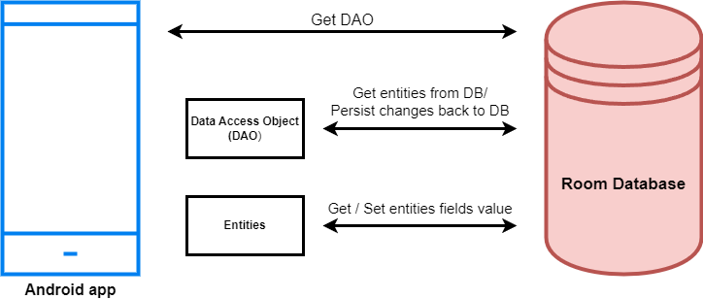

**Learning Outcomes :**

By end of this project:

* You’ll be able to work on Android studio and build an app.
* You’ll be able to integrate the database accordingly.

**Project Workflow:**

* Users register into the application.
* After registration , user logins into the application.
* User enters into the main page
* User can view the subject themes on selecting theme he can read about it.

**Note:**

To complete the project you need to finish up the tasks listed below:

**Tasks:**

1.Required initial steps

2.Creating a new project.

3.Adding required dependencies.

4.Creating the database classes.

5.Building application UI and connecting to database.

6.Using AndroidManifest.xml

7.Running the application.

### Required Initial Steps

This milestone explains about Required Initial Steps

<https://developer.android.com/studio/install>

### Creating A New Project

Step 1 : Android studio > File > New > New Project > Empty Compose Activity

Step 2 : Click on **Next** button.

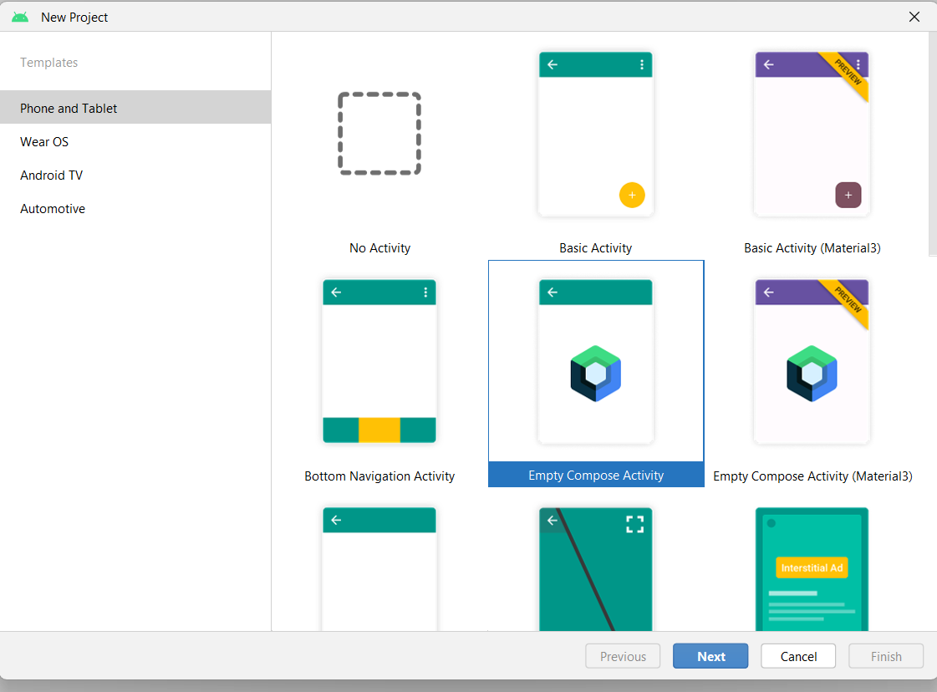

Step 3 : Give name to the new project.

Step 4 : Give the Minimum SDK value

Step 5 : Click Finish

**Main Activity File**

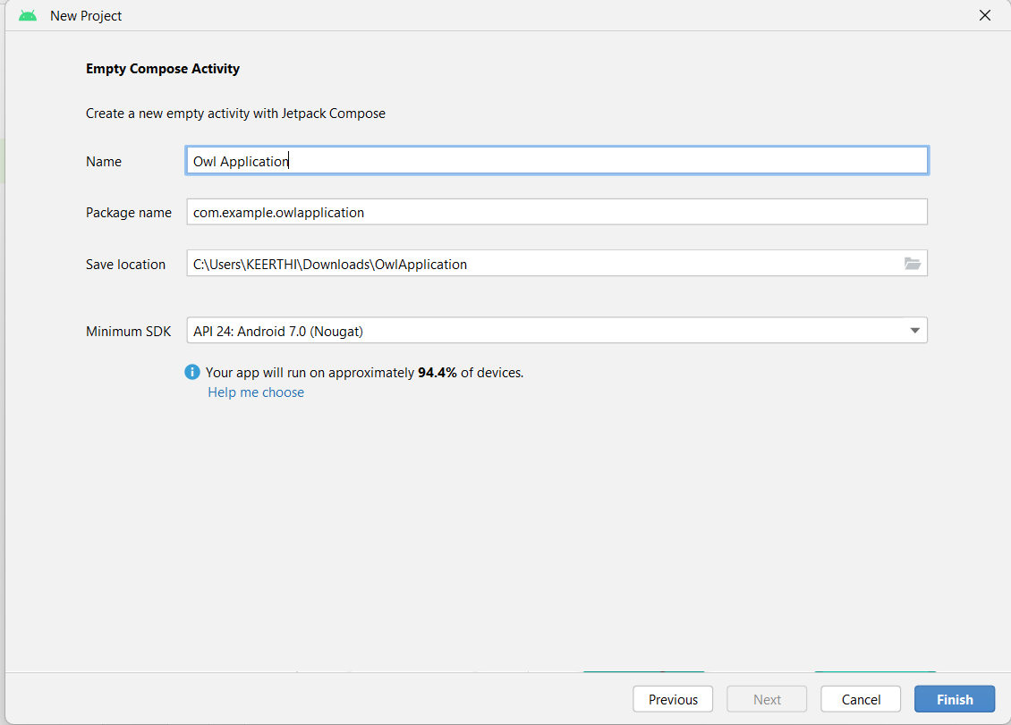

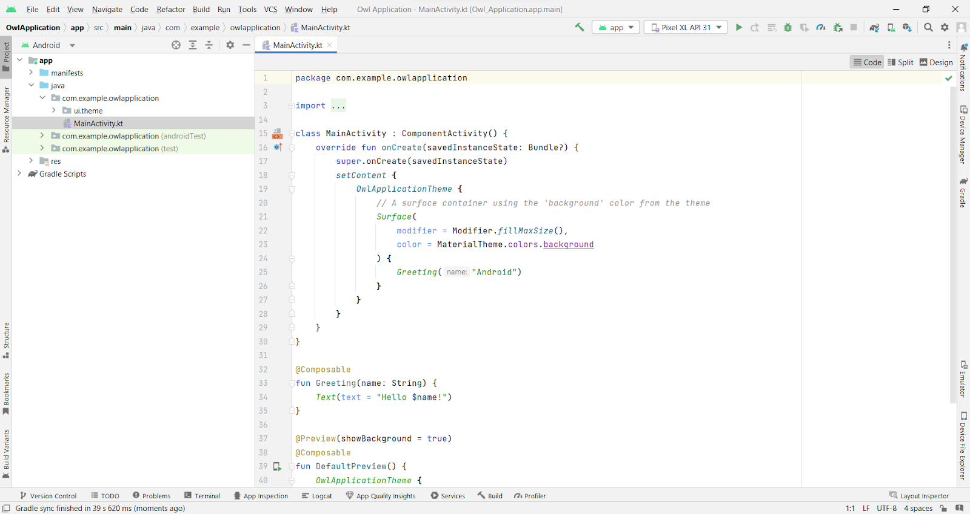

### Required Dependencies

This milestones explains about adding required dependencies.

### Gradle Scripts > Build.Gradle(Module :App)

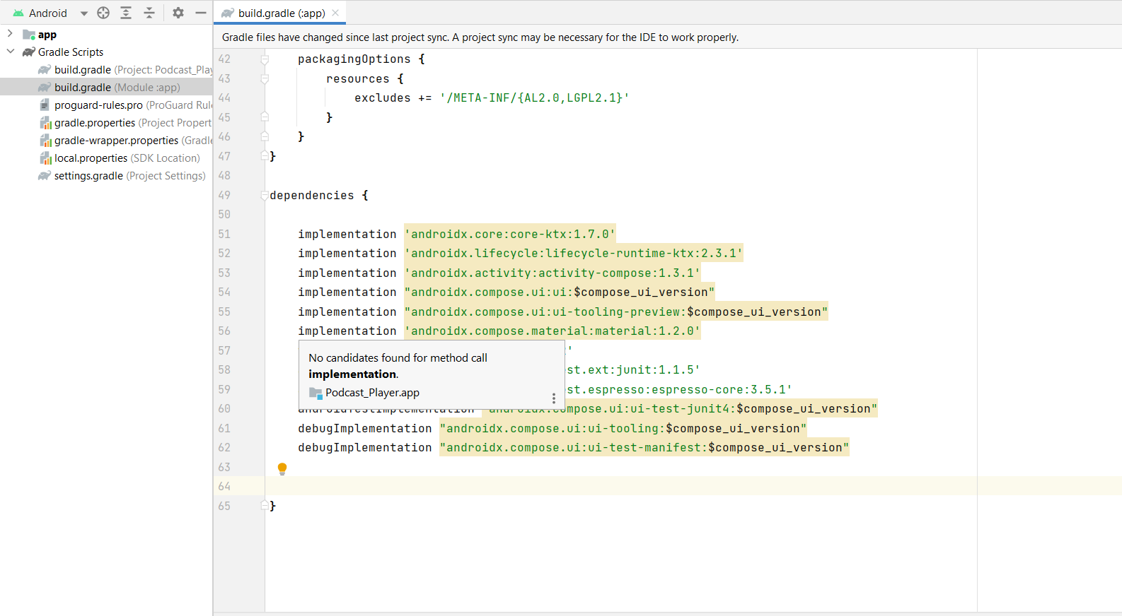

### Adding Room Dependencies

Add the below code in dependencies

*// Adding Room dependencies*

implementation 'androidx.room:room-common:2.5.0'

implementation 'androidx.room:room-ktx:2.5.0'

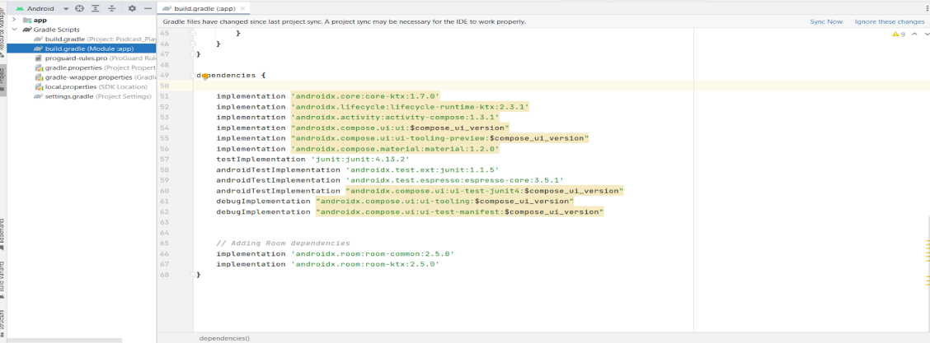

Step 3 : Click on Sync now

### Creating The Database Classes

This milestone explains about Creating the database classes

### Create User Data Class

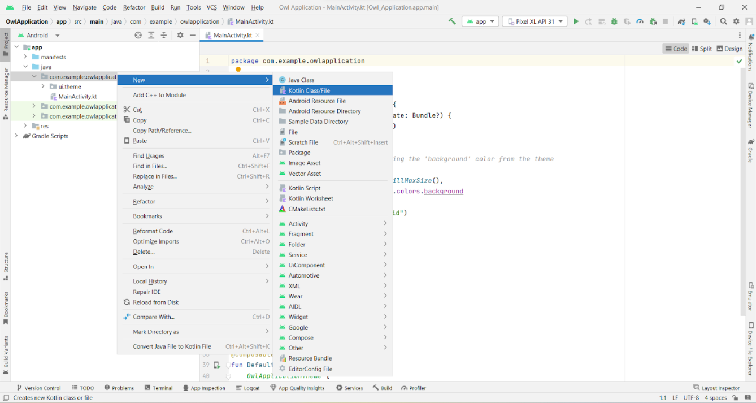

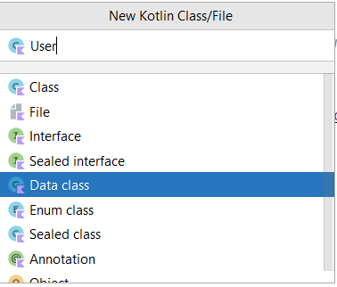

### Create An UserDao Interface

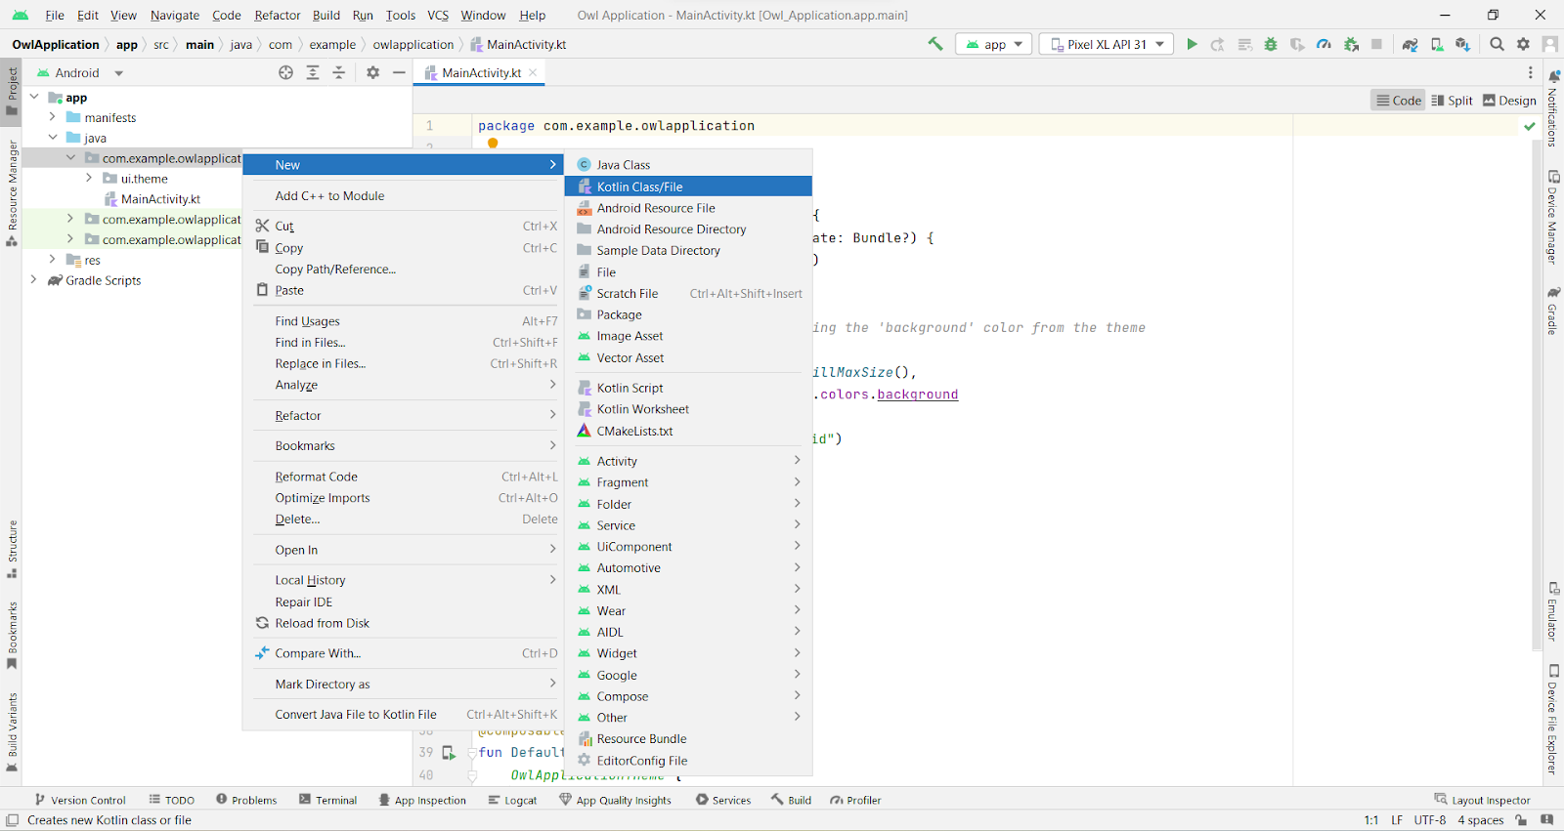

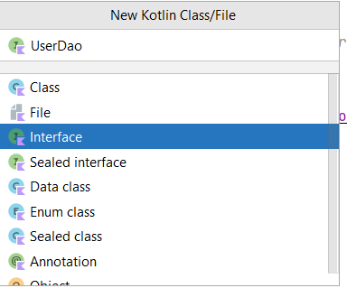

### Create An UserDatabase Class

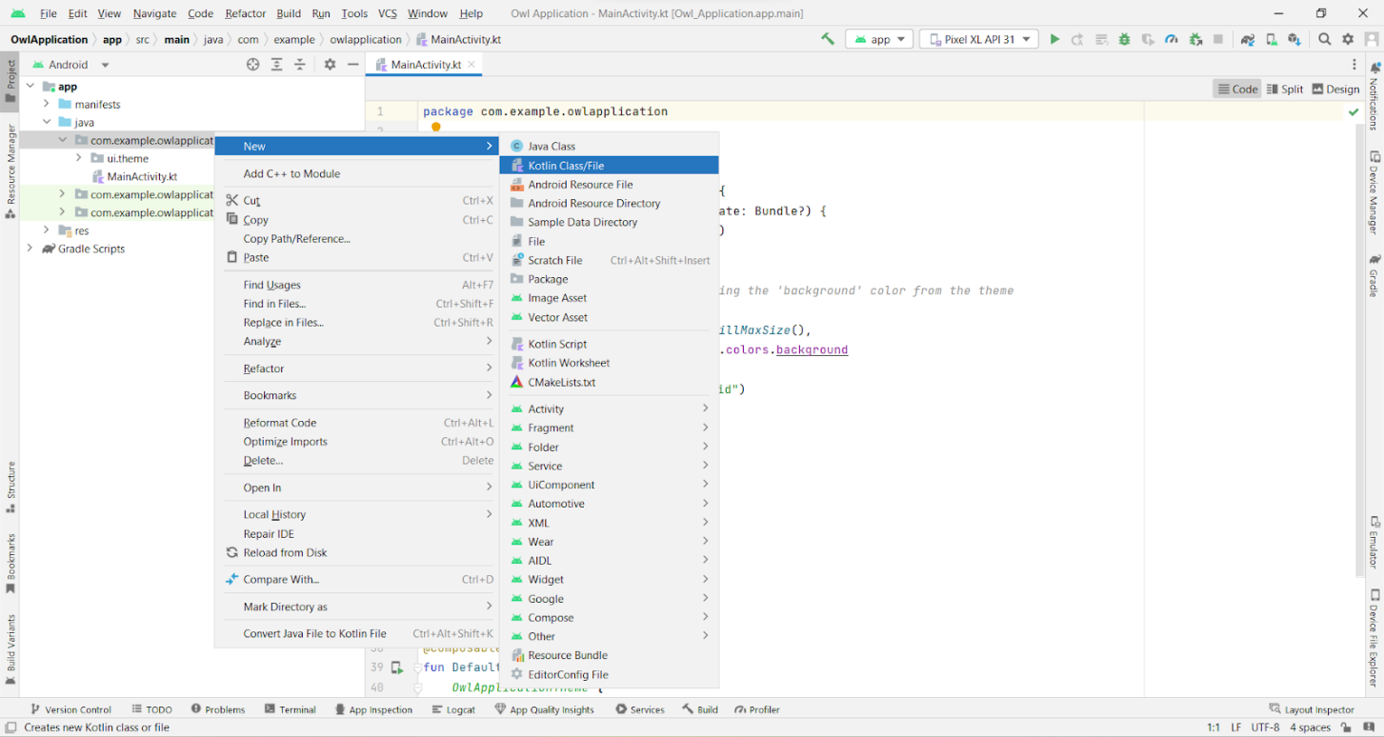

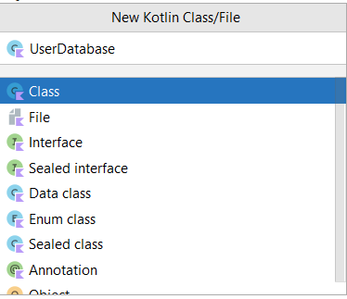

### Create An UserDatabaseHelper Class



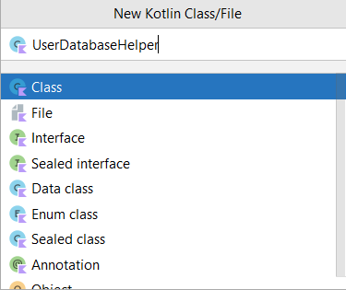

### Building Application UI And Connecting To Database

This milestone explains about Building application UI and connecting to database.

### Creating LoginActivity.Kt With Database

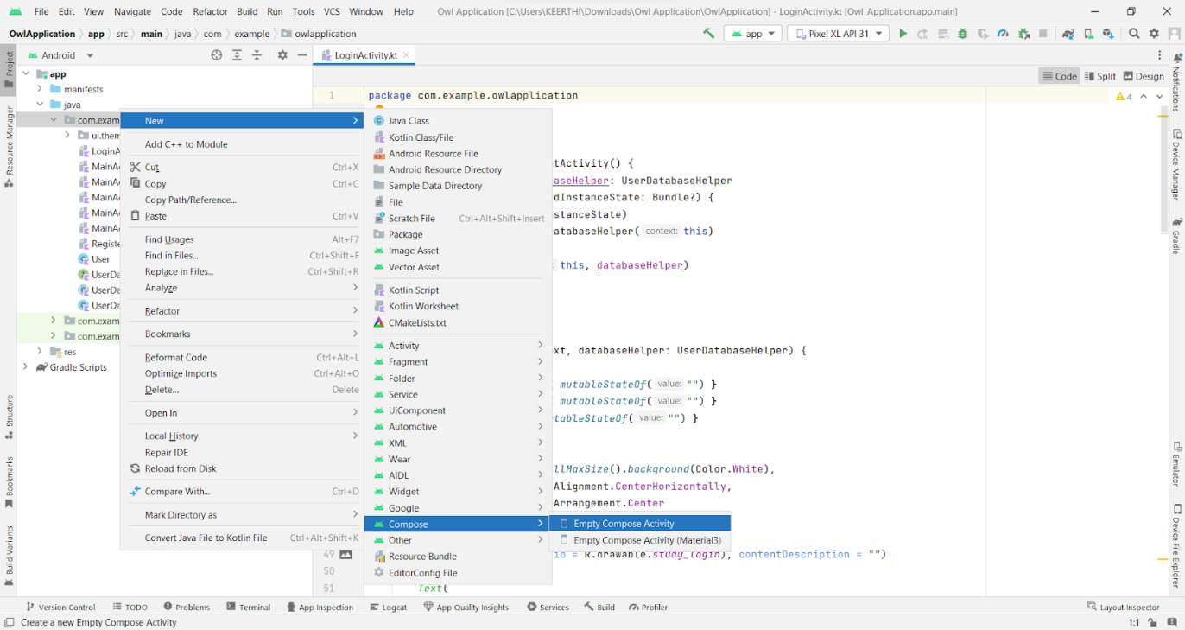

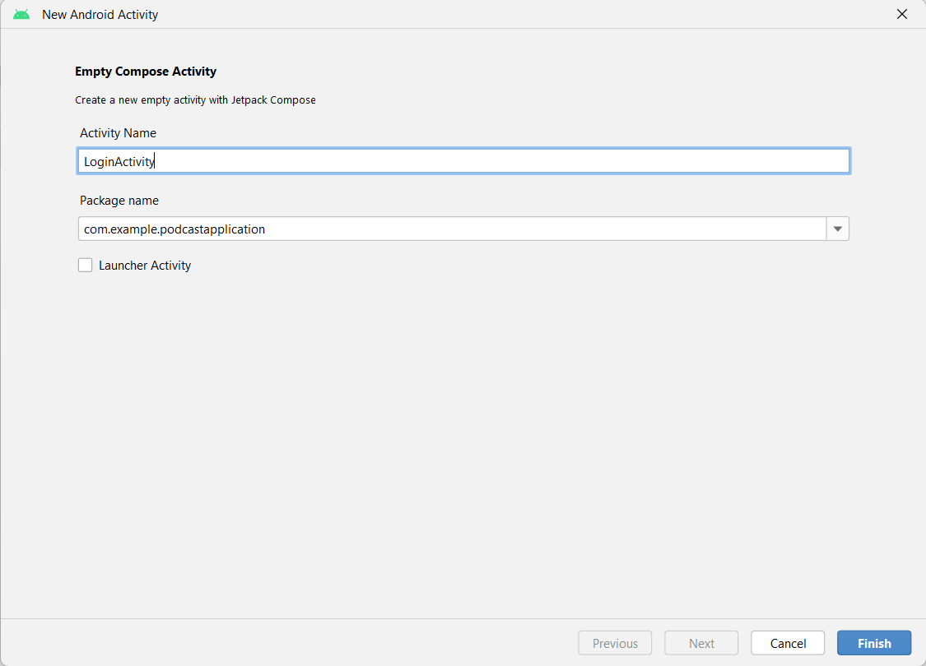

**Database connection in LoginActivity.kt**

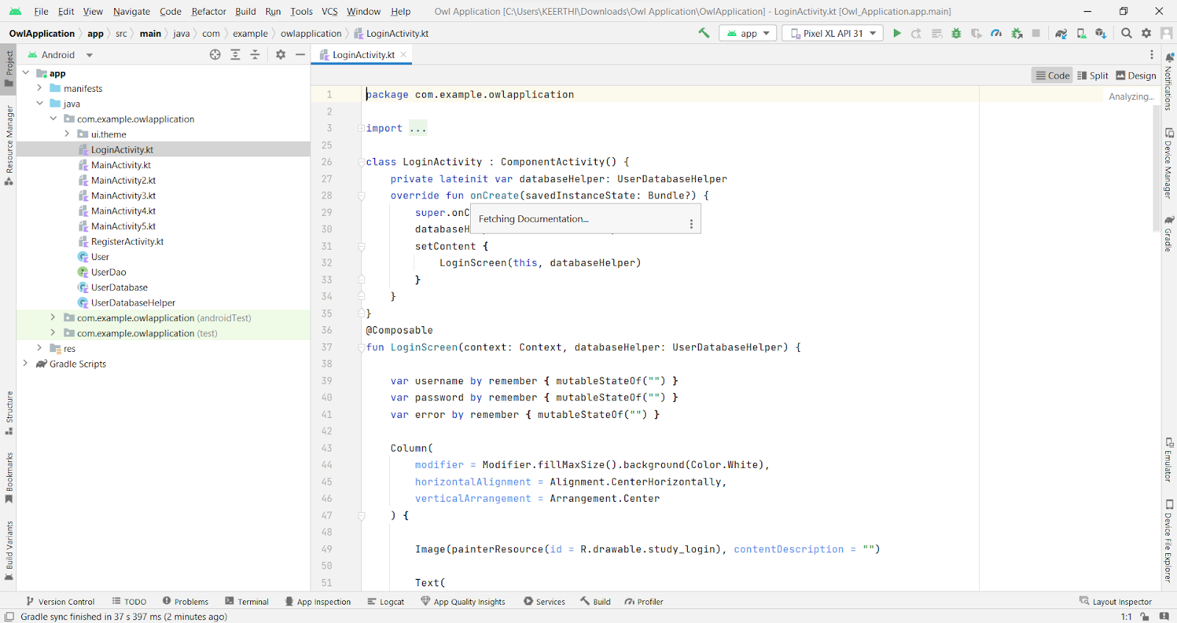

### Creating RegisterActivity.Kt With Database

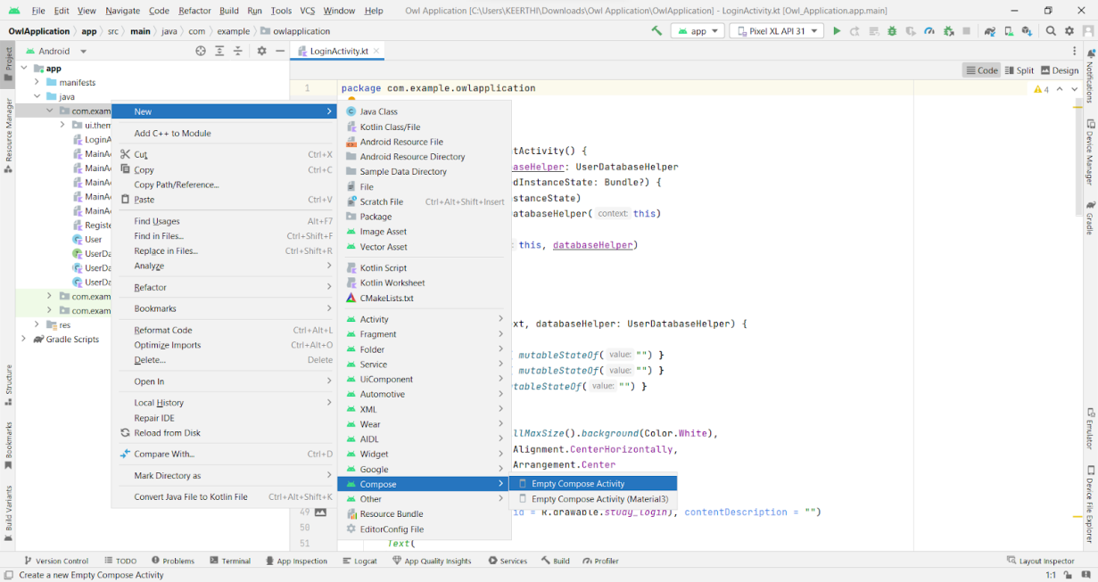

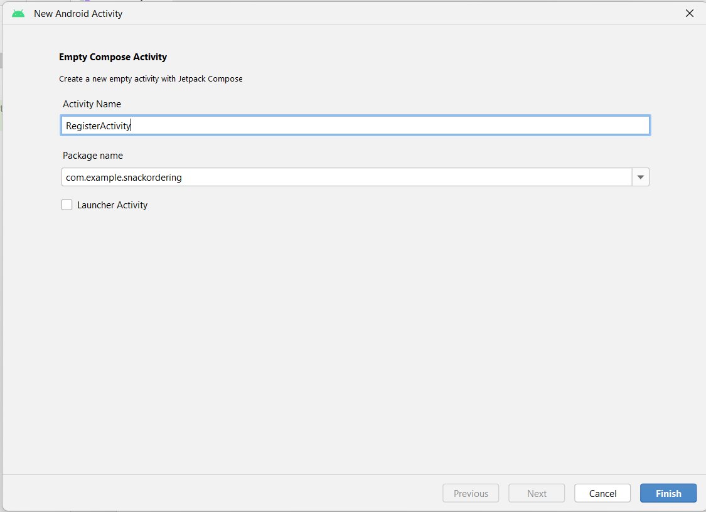

**Database connection in RegisterActivity.kt**

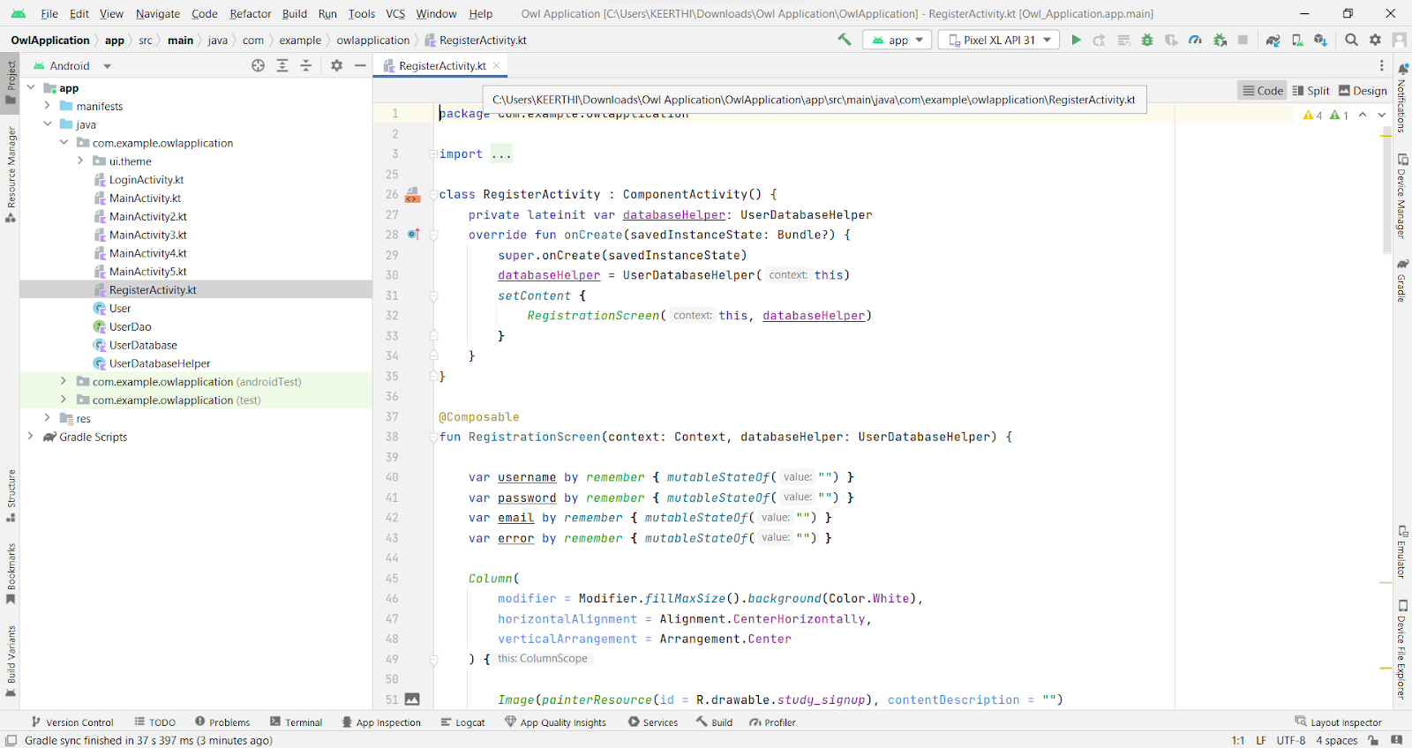

### 

### Creating MainActivity.Kt File

In MainActivity.kt file the main application is developed

* 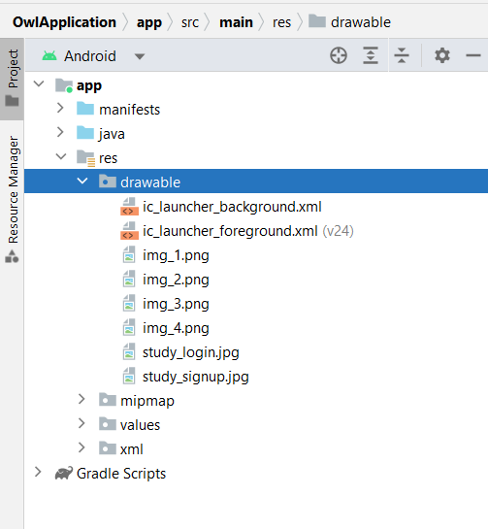Before creating UI we need to add some images in drawables which are in res

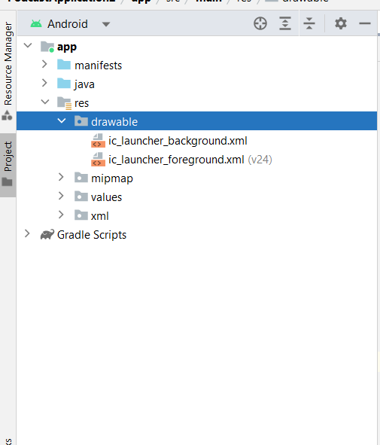

**MainActivity.kt**

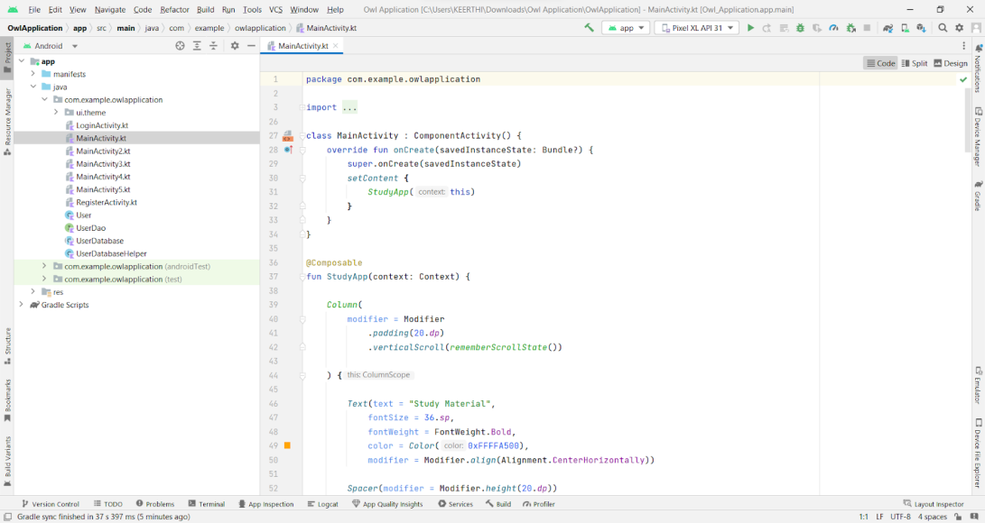

### Creating MainActivity2.Kt File

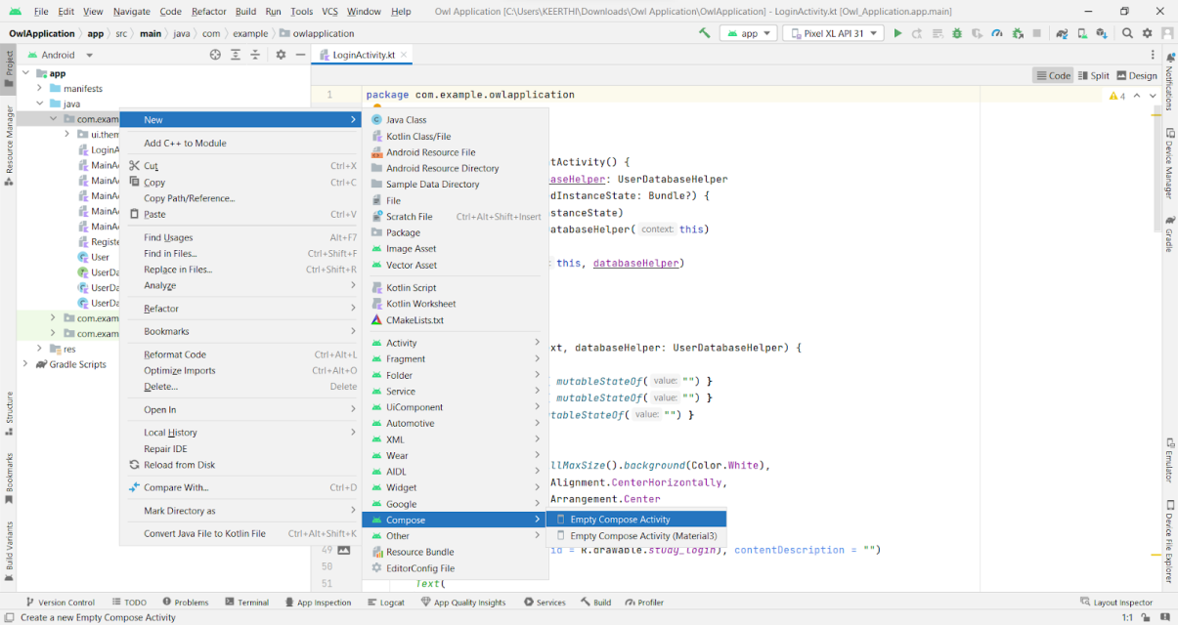

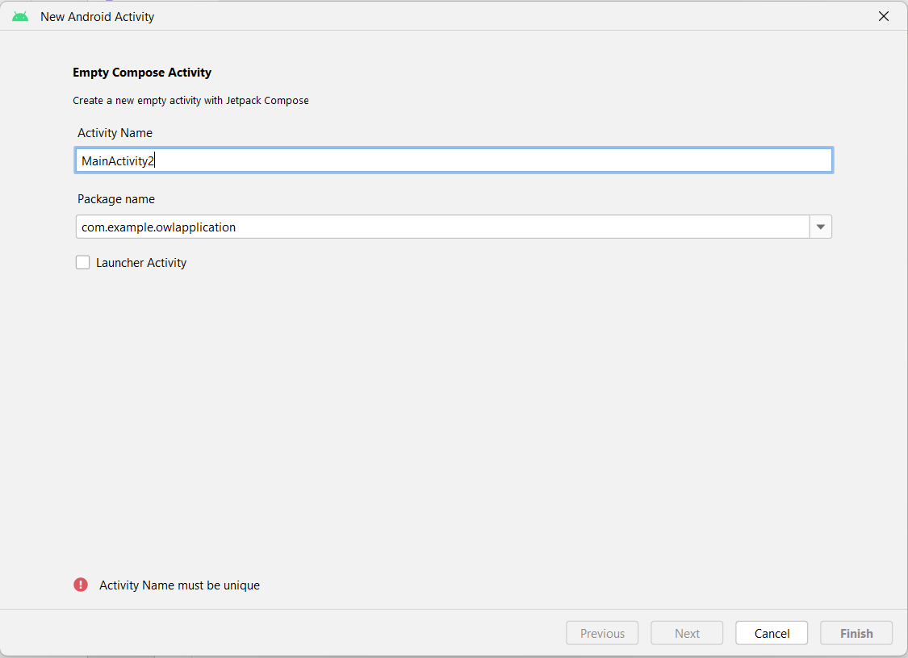

**MainActivity2.kt**

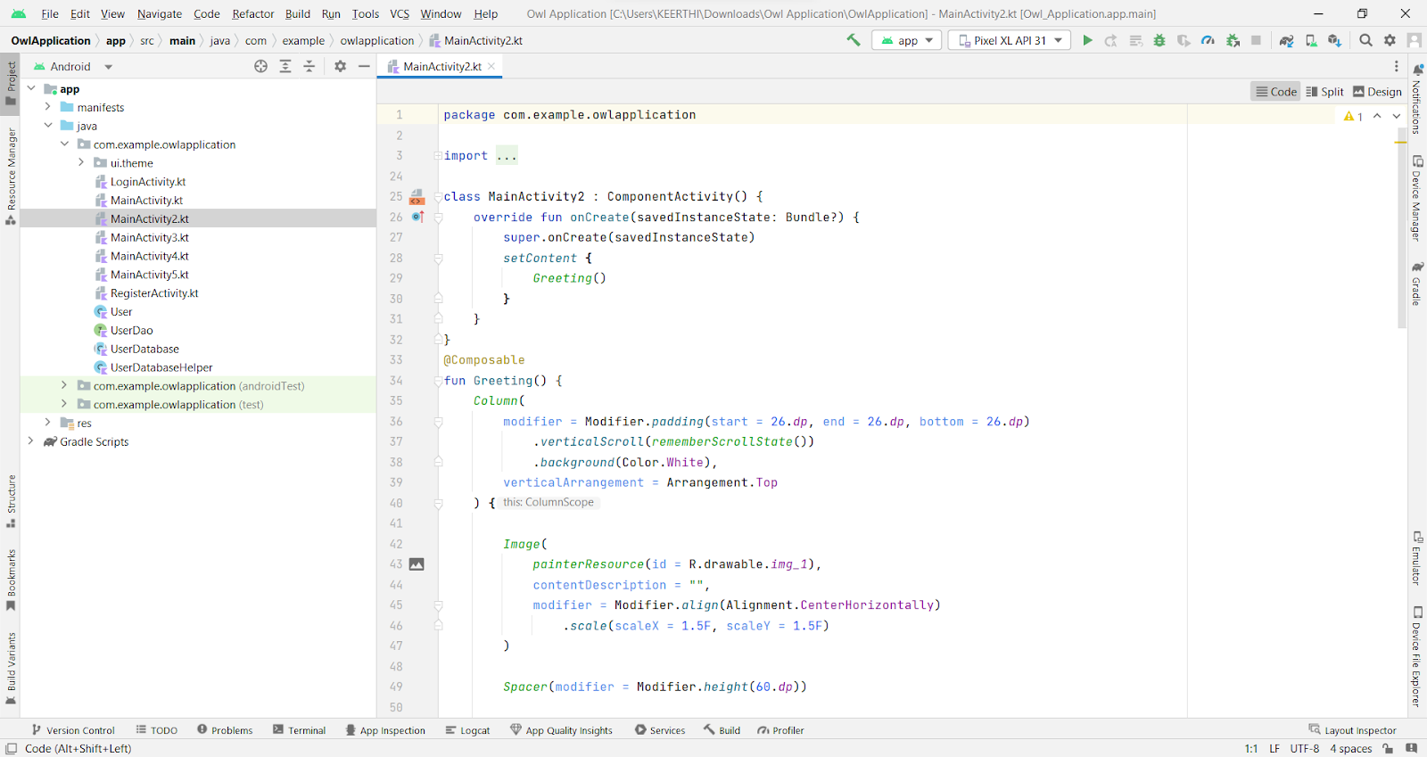

### Creating MainActivity3.Kt File

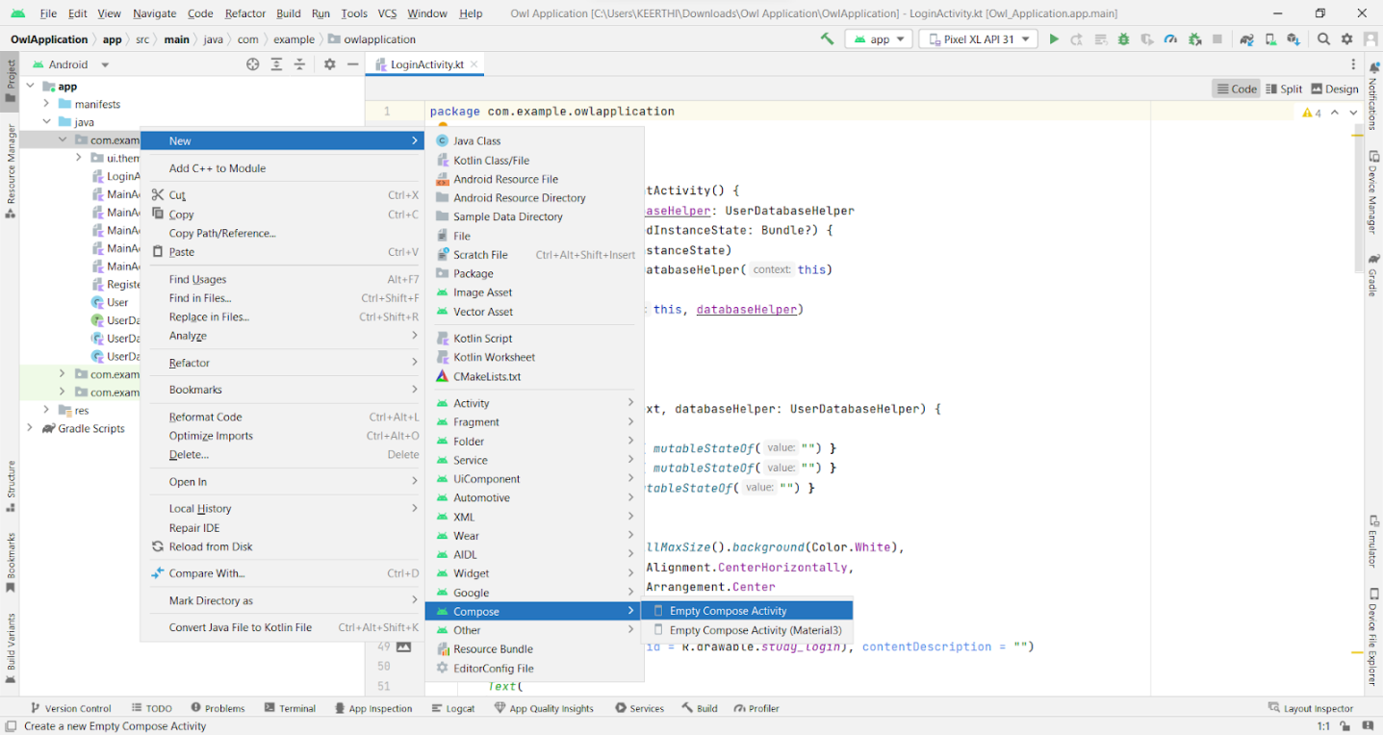

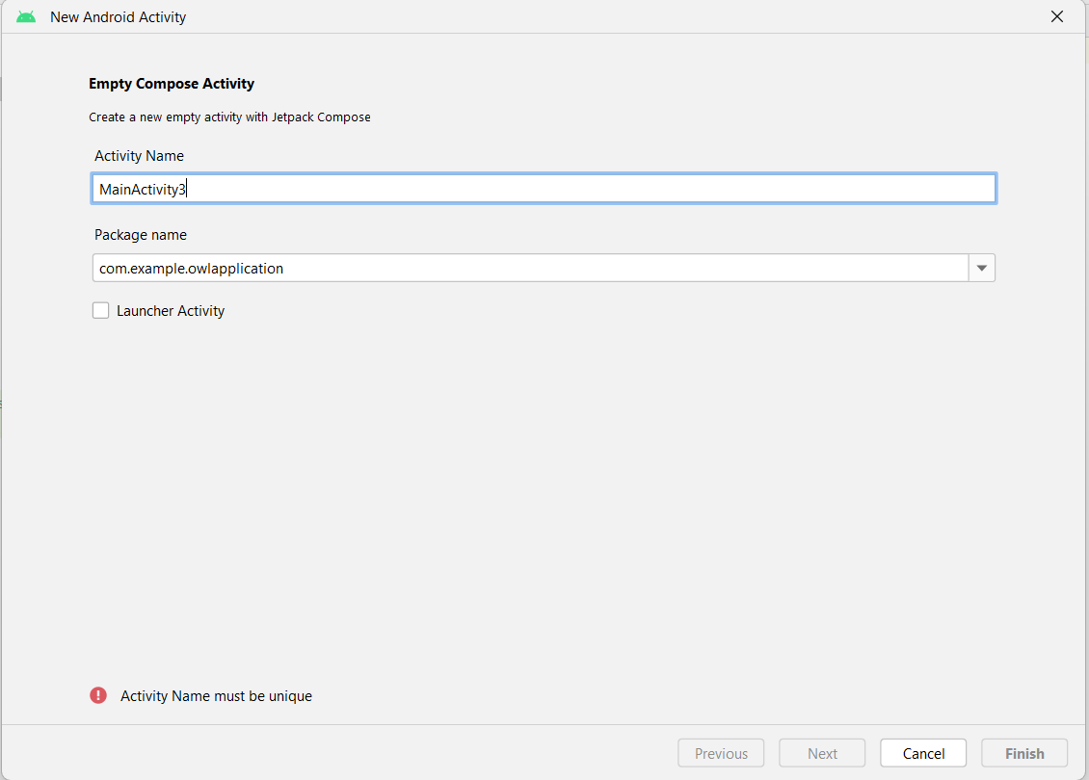

**MainActivity3.kt file**

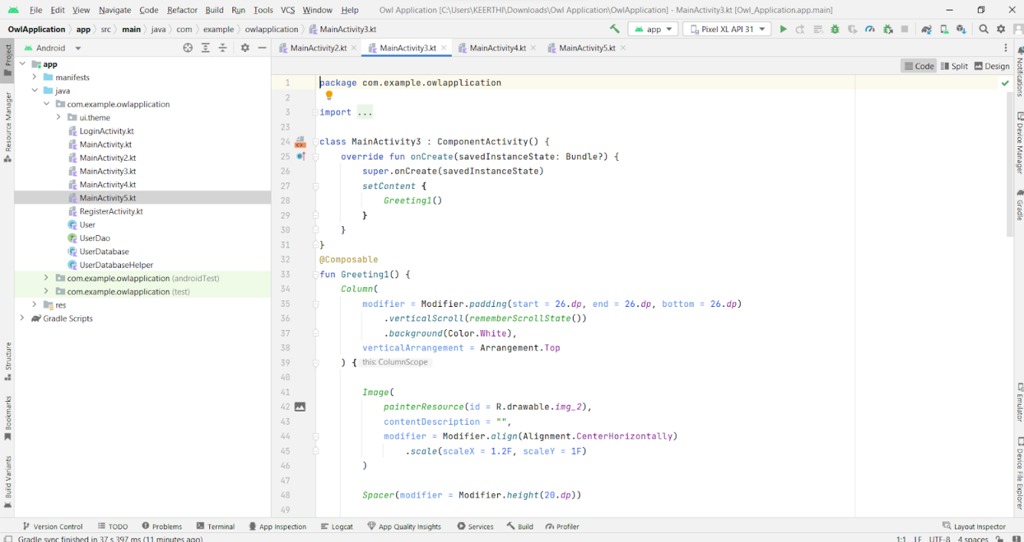

### Creating MainActivity4.Kt File

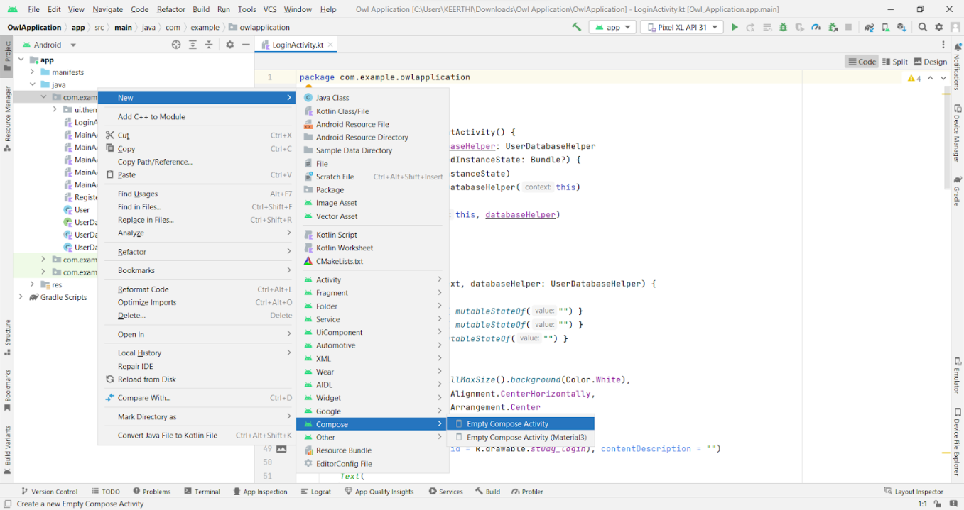

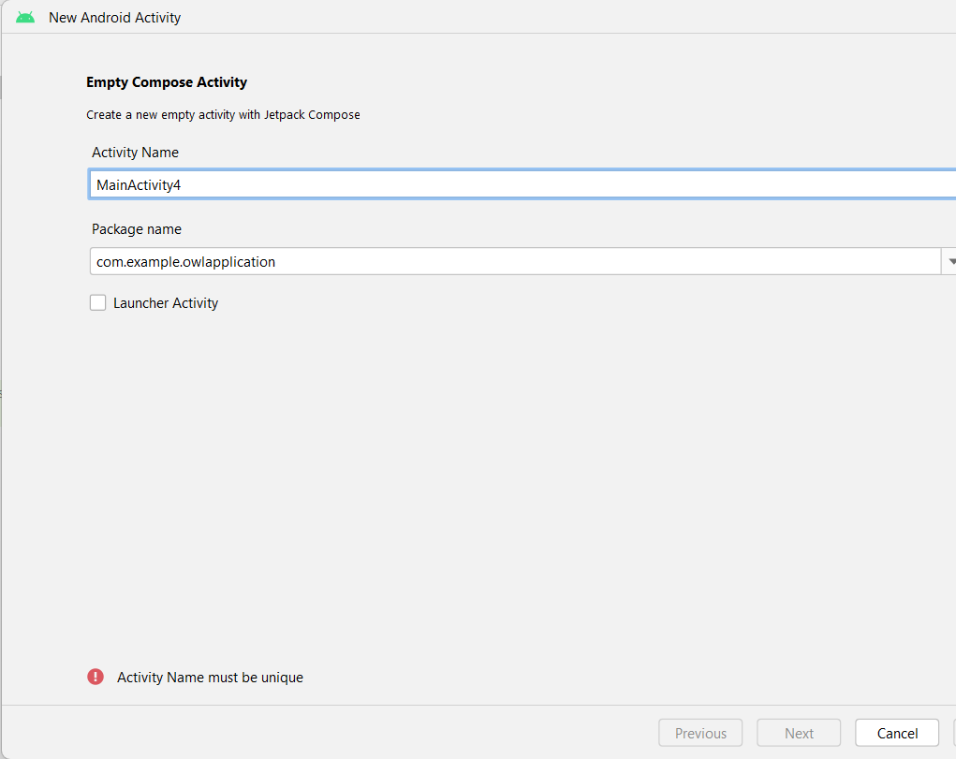

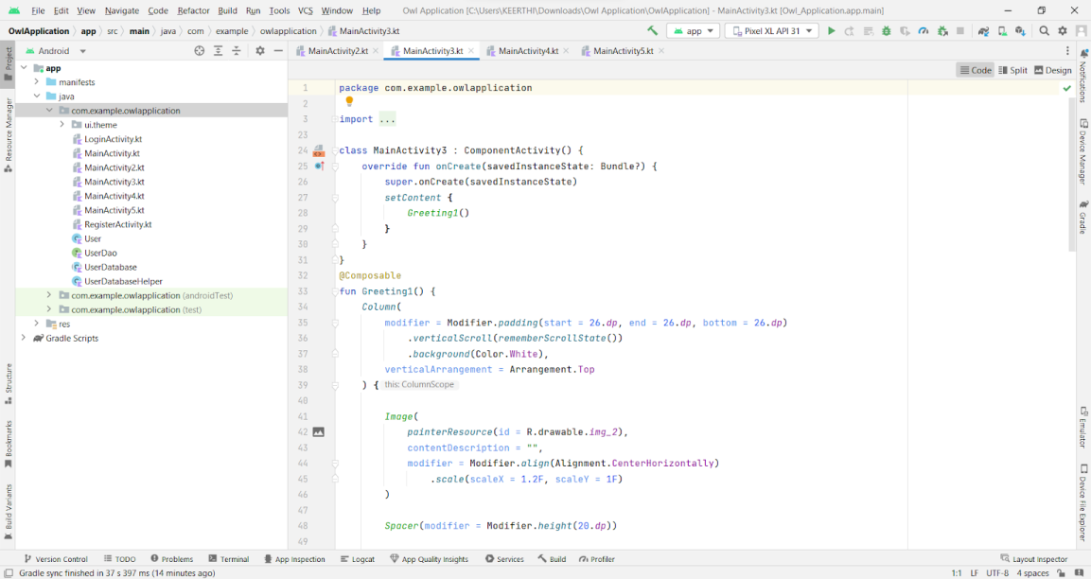

### Creating MainActivity5.Kt File

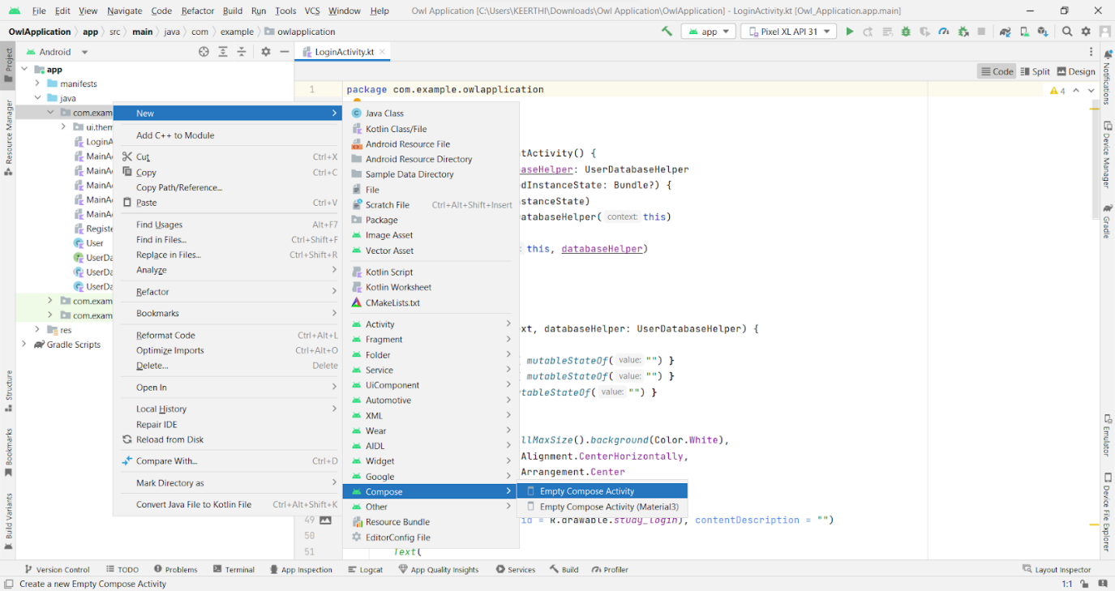

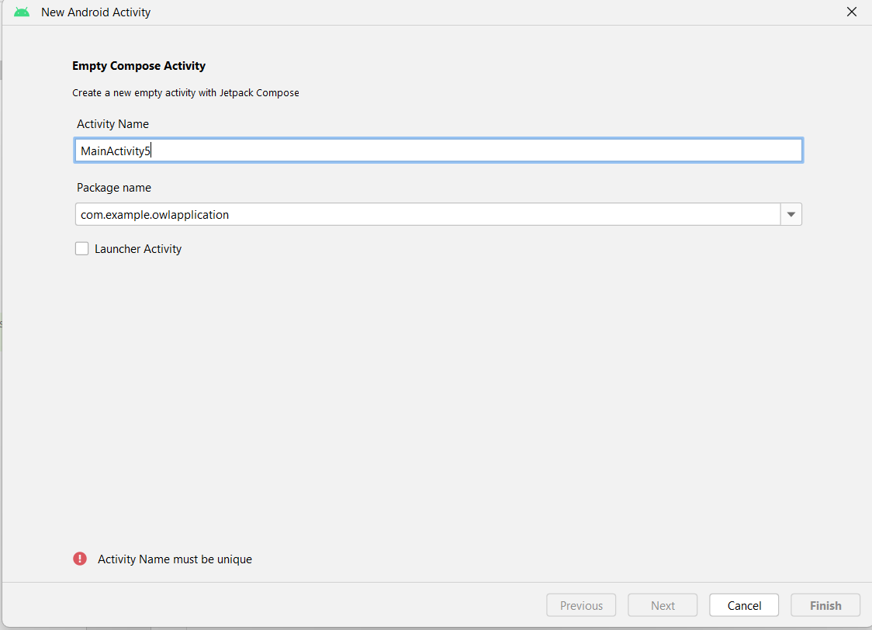

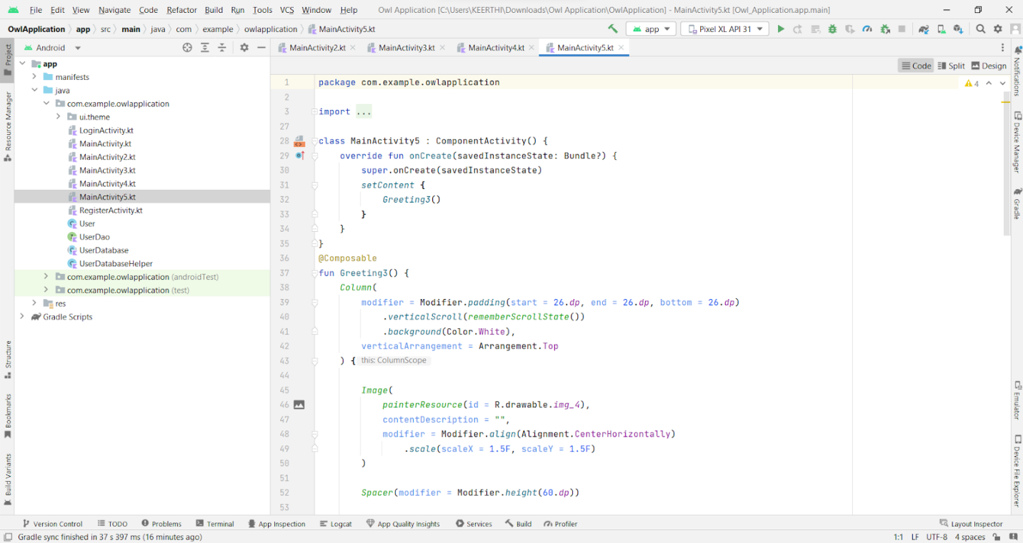

### Modifying AndroidManifest.Xml

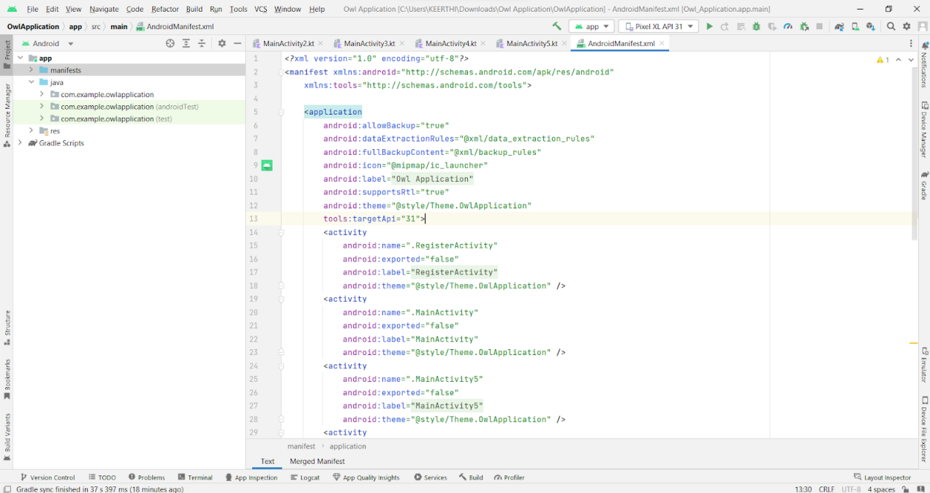

**When we run the app we will get the MainActivity.kt file as our first screen , but we want LoginActivity.kt , So we need to change in AndroidManifest.xml.**

**Changed AndroidManifest.xml**

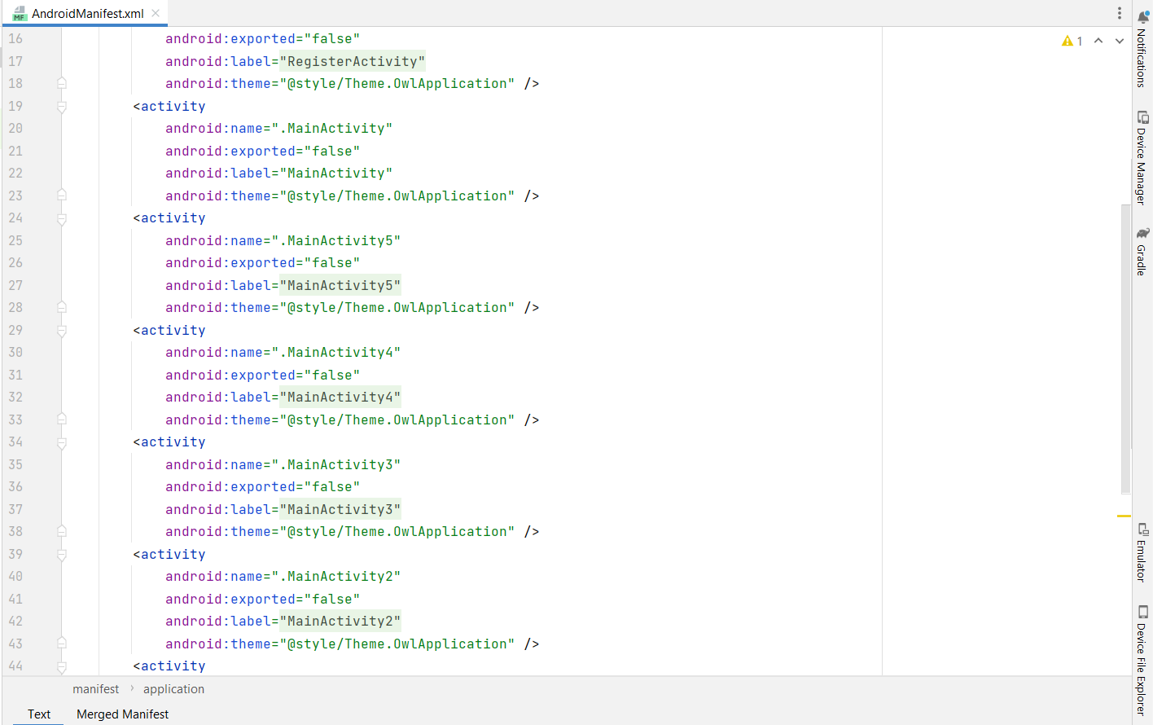

### Running The Application

This milestone explains about running the application.

### Run Apps On A Hardware Device

<https://developer.android.com/studio/run/device>

### Run The Application In Mobile

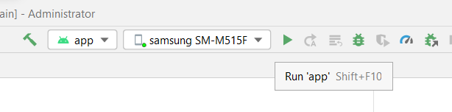

**Final Output of the Application :**

**Login Page : RegisterPage :**

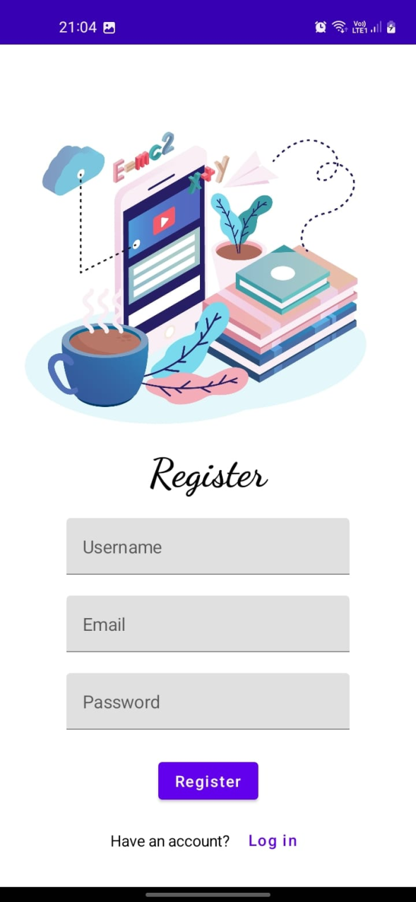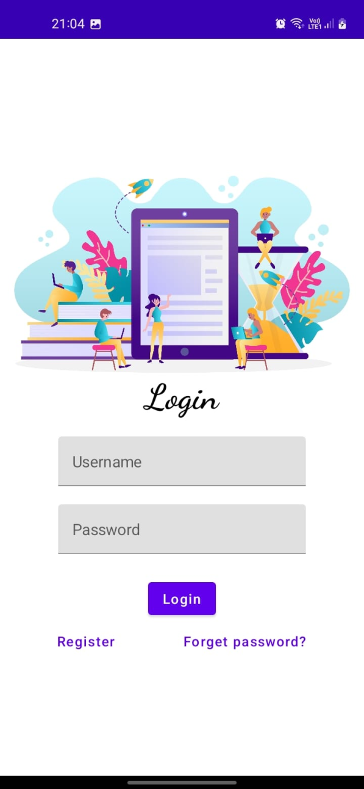

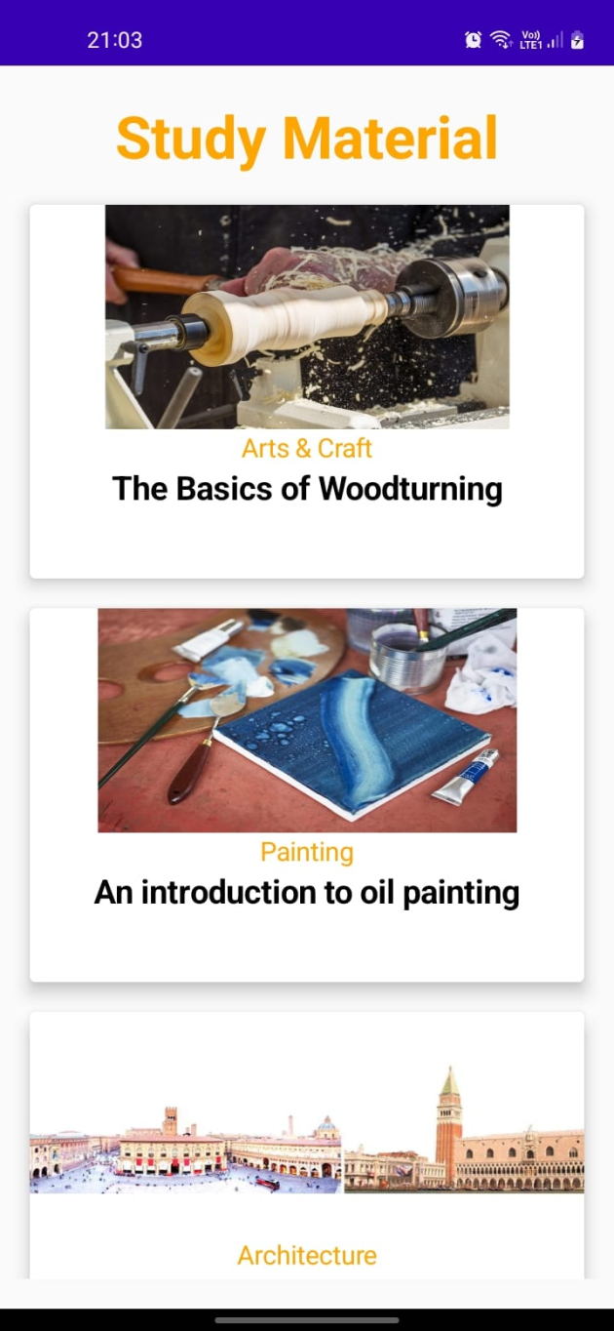**MainPage :**

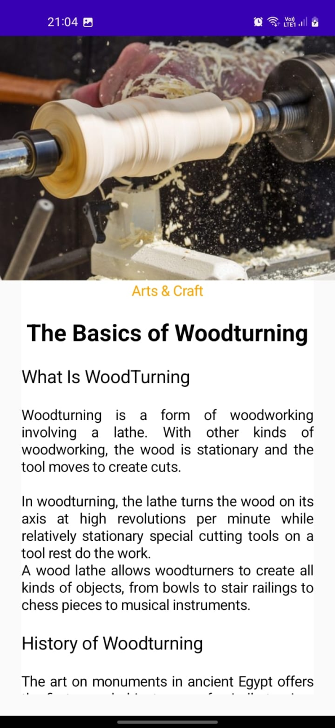 **Book page :**